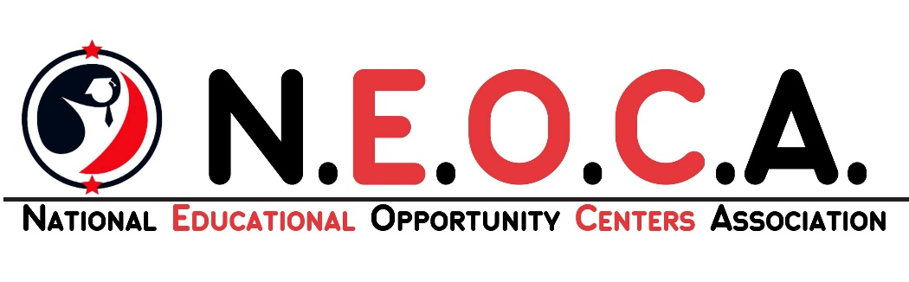

Melissa Rosa
NEOCA President Seminole State College Sanford, FL

Heather LaRue NEOCA Vice President
SKYCTC
Bowling Green, KY

Tarra Carson
NEOCA Treasurer
Grand Valley State Univ. Allendale, MI

Shawna Smith
NEOCA Secretary
Delta Sigma Theta, Inc.
Maryland EOC
Baltimore, MD

Matthew Donovan NEOCA Past President Morehead State Univ.
Morehead, KY
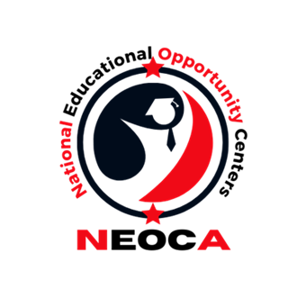
June 1, 2026

To: National Educational Opportunity Centers Association From: NEOCA Scholarship Committee
Re: NEOCA Annual Scholarship Competition

The National Educational Opportunity Centers Association announces its 2026 scholarship competition. NEOCA will award scholarships to help cover recipients' educational expenses during the 2026 - 2027 academic year. Six scholarships will be awarded, $1,000 each.

General Information:
Only applicants who’s sponsoring EOC TRIO program have a current NEOCA institutional membership will be considered.
- HS Equivalency Diploma to Postsecondary Enrollment Scholarship EOC participants who obtained a high school equivalency diploma during the 2025 - 2026 program year can compete for a one-time award of $1,000 if they have successfully completed a high school equivalency diploma and will enroll in college during the 2026 - 2027 academic year.

Postsecondary Enrollment Scholarship
EOC participants seeking postsecondary enrollment during the 2026-2027 academic year can compete for a one-time award of $1,000.
  - Nominations are limited to one per award per NEOCA Institutional Membership.
  - Nominations may be sent electronically by email to the Scholarship Committee by the program director or staff member by July 31st, 2026. A
$1,000 check will be presented to the winners’ EOC staff at the annual conference.
Applications will be evaluated according to the criteria outlined below.
The official announcement of the winners will be made at the NEOCA conference to be held on September 15, 2026. Nominating EOC programs will be notified by August 24, 2026.
Should you have any questions or need additional information feel free to contact the NEOCA Scholarship Committee.

NEOCA Scholarship Activities List Information Form

What to Submit:

- Scholarship Application Form accompanying this memorandum.
- Applicant Essay: Discuss a challenge you have faced during your academic journey and how you have worked to overcome that challenge. Explain how EOC has assisted you in your education journey.
- HS equivalency diploma verification and enrollment verification, if applicable.
- Letters of recommendation as indicated in the accompanying general and specific program qualifications.

Please email the above materials to our NEOCA account: neocatreasurer2021@gmail.com
Incomplete applications will not be considered.
Evaluative Criteria:

Applicant’s Essay: based on content, organization, creativity, and grammar | Up to 40 points
Recommendation Letter from EOC Program | Up to 30 points
Professional Letter of Reference | Up to 10 points
Total possible points | 80

Scholarship Qualifications

General Qualifications
All Scholarship Applicants Must:
- Be currently enrolled in an Educational Opportunity Center Program with current NEOCA institutional membership and:
  - Have successfully completed and received an HS Equivalency Diploma during the 2025 - 2026 academic year and will enroll in a college program of study in the upcoming academic year.
Or
  - Will enroll in a college program of study in the upcoming academic year.

- Submit HS Equivalency Diploma verification and proof of enrollment if applicable.
- Submit a typed personal essay 250-400 words, as outlined in the Scholarship Application.
- Submit a letter of recommendation from the sponsoring TRIO program on official letterhead, which highlights academic growth and potential, personal qualities, and overall accomplishments.
- Submit a letter of recommendation from a community or professional affiliate (employer, clergy, social worker, etc.).

2

National Educational Opportunity Centers Association Scholarship Application
Deadline: July 31, 2026
I am applying for:
 High School Equivalency to Postsecondary Enrollment Postsecondary Enrollment
Please attach all supporting documents:
- Scholarship Application Form
- Applicant Essay
- High school equivalency/GED verification and proof of enrollment if applicable
- Letters of recommendation as indicated in the general qualifications.

RECOMMENDING EOC PROGRAM INFORMATION:

Program Name:
Contact Person:
Phone: |  | E-mail Address:
Street Address:
City/State/Zip
APPLICANT INFORMATION:

Name:
Phone: |  | E-mail Address:
College Name:
Campus Address:
City/State/Zip
Personal Address:
City/State/Zip

Applicant Signature*
*I understand that my application essay may be used in future TRIO-related activities or publications. If chosen to receive a scholarship, I understand that I may be asked to provide proof of enrollment.
Applicant Signature: Date: _

EOC Staff Signature*
*By my signature, I certify that the student applying for this scholarship is a participant in the project that I work for and that they are otherwise eligible to compete for this award.
*Program Staff Signature Date:

NEOCA Scholarship Scoring Rubric
ITEM | DETAILED POINT VALUES | Possible Points
ESSAY  Essay must be between 250-400 words  (maximum) | Essay Prompt: Discuss a challenge you have faced during your academic journey and how you have worked to overcome that challenge. Explain how EOC has assisted you in your education journey. The essay is rated as follows:  - Content  - Communication skills (grammar, organization, creativity, punctuation, and spelling)  Total Possible Points – Essay = | Points:  1 – 35  1 - 5  40
TRIO Staff Recommendation Letter | The extent to which the following mentions are discussed:  - Growth and Potential  - Personal Qualities  - Overall Accomplishment  Total Possible Points – TRIO recommendation | Points:  0-10 points  0-10 points  0-10 points  ----------30
Professional Letter of Reference | As long as a professional reference letter is provided then all points will be awarded. Without a professional letter of reference, zero points will be awarded.  Total Possible Points – Professional Letter of Reference | Points:  10

