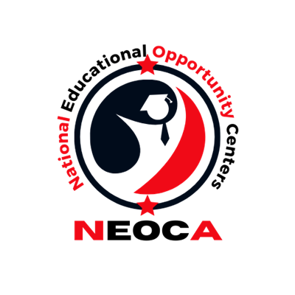
Hyatt Regency Chicago
151 East Wacker Drive
Chicago, Illinois 60601

Saturday, September 6, 2025
10:00 am (CST) *11:00 (EST) *9:00 (MST) *8:00 (PST)
Michigan 1, Concourse Level East Tower

Note: The Order/Activities Are Subject To Change.

Breakfast on your own

9:00 a.m. Registration Opens (Outside of Michigan 1)

9:15 am Virtual Conference Room Opens/Mix and Mingle

9:20 am Vendor Spotlight

10:00 am Introductions and Opening Remarks
Presenter: Matthew Donovan, NEOCA President

10:10 am Keynote Speaker
Presenter: Dr. Arnold Mitchem, COE President Emeritus

11:20 am Roundtable Discussion
Presenter: Rico Drakes & Melody Lawrence

12:30 pm Lunch On Your Own – Paid for by NEOCA

2:15 pm Department of Education Debrief and Member Input Session
Presenter: Matthew Donovan, NEOCA President and Ashley Childs, NEOCA VP

2:40 pm NEOCA Awards Presentation
Presenter: Ashley Childs, NEOCA Vice-President

3:00 pm NEOCA Business Meeting
Presenter: Matthew Donovan, NEOCA President

3:45 pm Scholarship Presentation
Presenter: Ashley Childs, NEOCA Vice-President

4:00 pm COE Update
Presenter: Council for Opportunity in Education Representatives

4:30 pm Closing Remarks
Presenter: Matthew Donovan, NEOCA President

