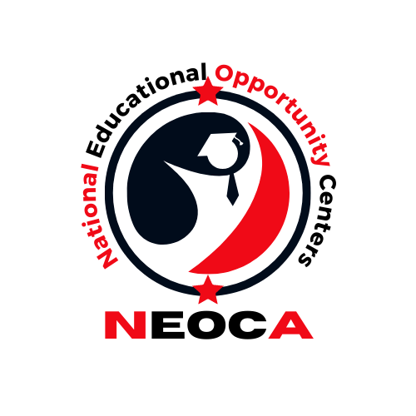

Annual Conference Business Meeting
Washington, DC
September 9, 2023

3:00 p.m. Meeting Called into Session
- Meeting Call to Order – Mr. Lee Williams III, NEOCA President
- Roll Call – Mrs. Ikisha Cross, NEOCA Secretary
- Approval of the Minutes from 2022 – Mrs. Ikisha Cross, NEOCA Secretary
Report of Officers
- President’s Report – Mr. Lee Williams III, NEOCA President
- Vice President’s Report – Mrs. Tonya Harris, NEOCA Vice President
- Treasurer Report – Mr. Matthew Donovan, NEOCA Treasurer
- Secretary Report – Mrs. Ikisha Cross, NEOCA Secretary
      - NEOCA Scholarship (Scholarship Committee Chair)
Old Business
3:30 p.m. New Business
- NEOCA Budget 2023-2024

3:45 p.m. NEOCA Election
4:00 p.m. NEOCA Scholarship Presentation
4:30 p.m. COE Update

