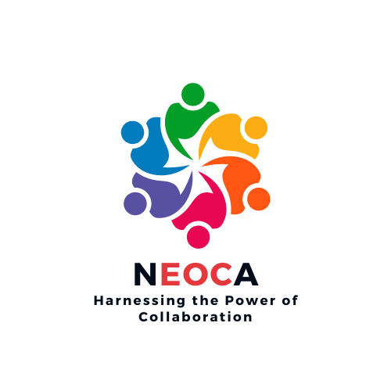
2023 NEOCA Annual Conference Agenda

The Washington Hilton
1919 Connecticut Ave., NW
Washington D.C. 20009

Saturday, September 9, 2023

10:00 (EST) * 9:00 (CST) * 8:00 (MST) * 7:00 am (PST)

Breakfast on your own

9:00 a.m. Registration

9:45 am Virtual Conference Room Opens/Mix and Mingle

10:00 am Introductions and Opening Remarks
Presenter: Mr. Lee Williams III, NEOCA President

10:10 am Emotional Civility
Presenter: Rev. Dr. Sharon Styles Anderson, Esq.

11:20 am Adult Career Navigation
Presenter: Jim Giovannini

12:05 pm Being Broke Ain’t Sexy
Presenter: Eric Smith

1:00 pm NEOCA Service and Awards Luncheon

2:00 pm U.S. Department of Education Update/ Roundtable Discussion
Presenter:

3:00 pm NEOCA Business Meeting/Elections
Presenter: Mr. Lee Williams III, NEOCA President

4:00 pm Scholarship Presentation
Presenter: Ikisha Cross, NEOCA Secretary

4:30 pm COE Update
Presenter: Dr. Maureen Hoyler, Council for Opportunity in Education President

5:00 pm Closing Remarks
Presenter: Mr. Lee Williams III, NEOCA President

