2023 NEOCA Annual Conference Agenda – Tentative
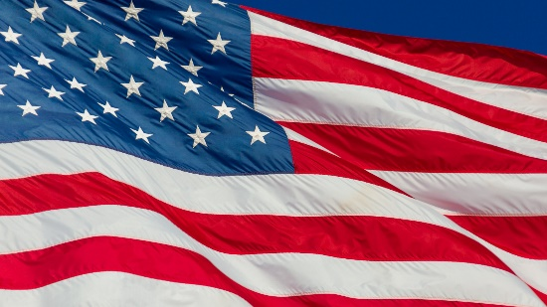

The Washington Hilton
1919 Connecticut Ave., NW
Washington D.C. 20009
NEOCA

Saturday, September 9, 2023

10:00 (EST) * 9:00 (CST) * 8:00 (MST) * 7:00 am (PST)

Note: This is a tentative agenda and the order of activities is subject to change. The Start time is set.

Breakfast on your own

9:00 a.m. Registration

9:45 am Virtual Conference Room Opens/Mix and Mingle

10:00 am Introductions and Opening Remarks
Presenter: Mr. Lee Williams III, NEOCA President
Texarkana College Texarkana, Texas

10:10 am Keynote: - TBD
Presenter:

11:20 am Presentation - TBD

12:30 pm Lunch

1:00 pm NEOCA Scholarship Presentation
Presenter: Ms. Ikisha Cross, NEOCA Secretary
Opportunity Resource Services
Cleburne, TX

2:30 pm NEOCA Business Meeting
Presenter: Mr. Lee Williams III, NEOCA President

3:00 pm EOC Share Session(s)
Round table discussions
Afternoon snacks

4:00 pm COE Update
Presenter: Dr. Maureen Hoyler, President Council for Opportunity in Education
Washington, DC

4:30 pm NEOCA Business Meeting – Conclusion
Presenter: Mr. Lee Williams III, NEOCA President

