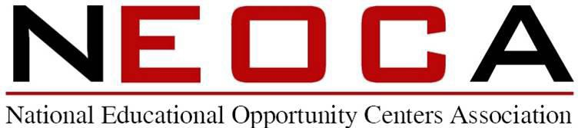

Annual Business Meeting San Diego, CA
September 20, 2022

1:20 p.m. Meeting Called into Session (After Scholarship presentations)
- Call Meeting to Order – Mr. Lee Williams III, NEOCA President
- Roll Call – Ms. Ikisha Cross, NEOCA Secretary
- Approval of the Minutes from 2021 – Ms. Ikisha Cross, NEOCA Secretary

Report of Officers
- President’s Report – Mr. Lee Williams III , NEOCA President
- Vice President’s Report – Mrs. Tonya Harris
    - NEOCA 2022 Conference Committee Chair
- Treasurer Report – Mr. Matthew Donovan
- Secretary Report – Ms. Ikisha Cross
    - NEOCA 2022 Scholarship Committee Chair
  - Past President’s Report – Mateo Arteaga

Old Business

1:40 p.m. New Business
- NEOCA Fair Share Donation for 2022 – Mr. Matthew Donovan

2:00 p.m. Adjournment of Business Meeting or break if the meeting is not finished

2:00 p.m. COE Update with Maureen Hoyler, President, Council for Opportunity in Education

2:30 p.m. Conclusion of NEOCA 2022 Business meeting if needed.

